**Brooklyn torah gazette**

**For parshas toldos 5780**

Volume 4, Issue 11 (Whole Number 163) 2 Kislev 5780/ November 30, 2019

**Printed L’illuy nishmas Nechama bas R’ Noach, a”h**

For a free subscription, please forward your request to [***keren18@juno.com***](mailto:keren18@juno.com)

**The Importance in Judaism**

**Of Having Many Children**

**By Daniel Keren**

The very first mitzvah (commandment) that G-d gavemankind was “to be fruitful and multiply” (Bereishis/Genesis 1:28) and this is reemphasied in the account of Noach where after the flood and the exiting from the Ark, this command was restated: “And G-d blessed Noah and his sons, and He said to them ‘Be fruitful and multiply and fill the earth” (Bereishis 9:1)

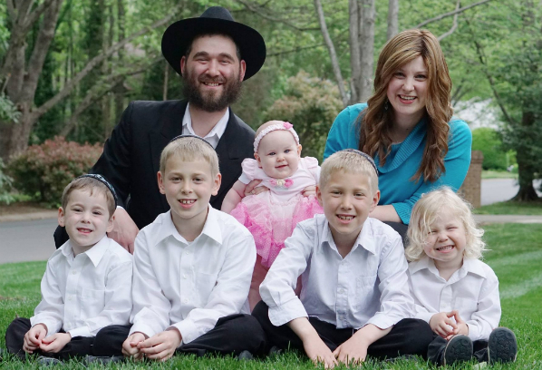

Up until about 50 or 60 years ago most families in the Jewish world (in America and Eretz Yisroel, especially after the Holocaust) believed that having children was important and this was regardless of whether the family was religious or secular.

And then in 1968, Paul Ehrlich, a professor at Stanford University published an alarmist book titled “Population Bomb” that predicted the world’s rapidly growing population was going to result in the starvation of hundreds of millions of people as soon as the 1970s and 1980s. That prediction never occurred and indeed the food technology has incredibly multiplied and avoided the problem of mass starvation. In fact today the problem in countries around the world (including China and India) is more related to obesity and the many medical ills that ailent creates such as diabetes and heart disease.

Another reason why couples in both the industrialized and developing world are limiting the size of their families is because they think that having children is too difficult and cuts into the romanticized style of living they would like to pursue (and which has been influenced by the books they read and the movies and television programs they have watched.

In both North America and the Land of Israel, it is predicted that by the middle of this century the majority of Jews will be Orthodox. While this may be fueled by the baal teshuvah movement (where many secular Jews have opted to adopt a Torah lifestyle,) the main reason is that Orthodox Jewish families have larger families whereas assimilated Jews have unfortunately bought into the fears of the population explosion and marry later and on average have less than 2.1 children that is recognized as the number of offspring required to just maintain the population.

Countries with less than 2.1 children per couple are already (i.e. Japan, Korea, Italy, Germany and other industrialized countries) beginning to experience major drops in population. Other nations such as China and India will go through similar population decreases in the next few decades.

And these population decreases are not positive. I seriously recommend googling the youtube program “Empty Planet: Preparing for Global Population Decline.” Some of the points brought out by Darrell Bricker and John Ibbitson in their recent book “Empty Planet: The Shock of Global Population Decline” is quite startling and disturbing.

Countries with major population declines will experience a greater percentage of elderly citizens and too few young people in the work force to be able to support the Medicaire or Social Security type programs.

In Judaism, Chazal (our Sages of blessed memory) in the Talmud (Yevamos 62a) taught that Moshiach “The son of David will not come until there are no more souls in the [Heavenly storage house called] guf. Rabbi Aryeh Citron in his article “Be Fruitful and Multiply” for Chabad.Org quotes the Midrash (Tana Devei Eliyahu Zutah) that tells us “Just like the Jews were redeemed from Egypt in the merit of having children [despite the terrible brutalities of slavery in Mitzrayim], so too they will be redeemed in the future in the merit of having children.”

There is no denying the fact that families with smaller number or children or even no children can have a very fancy materialistic style of life. But for Jewish religious families, the challenge is to not get overly influenced by the environment around us which is patently not against the Torah values we desire.

By struggling in our youth and middle age to have and raise large families properly, we will have the joys of grandchildren and great-grandchildren in our golden age and will enjoy the nachas victories of the marathon runner. The goal of every Jew is to make a reality of the Torah teaching that when a man and woman get married, they become partners with G-d in the creation of children and the future of the world.

**When a Charity Collector Asks for Money**

**By** [**Rabbi Moshe Meir Weiss**](https://www.jewishpress.com/author/rabbi-moshe-meir-weiss/)



We are taught, “Maaseh Avos siman l’bonim – The behaviors of our Patriarchs are a sign for how we should behave.” The Avos set the standard for all Jews to follow. Thus, when the Torah teaches us that Avraham pitched Sarah’s tent before pitching his own, he was setting the bar that one should take care of his wife’s needs before taking care of his own needs.

And when Sarah referred to Avraham as “Adoni zaken – My lord is old,” she was exhibiting the reverence a wife should feel for her husband. When Avraham sent Yitzchak to the yeshiva of Shem v’Eiver, he was illustrating that parents should send their children away from the home to an environment of Torah study. And when Yitzchak offered his neck at the Akeidah, he was injecting into the Jewish bloodstream the power of martyrdom.

I’d like to zoom-in on one specific example of maaseh Avos siman l’bonim: Namely, when Avraham trail blazed the way of giving charity. The Torah tells us that when Avraham had his famous encounter with the venerable Shem, the son of Noach, “Vayiten lo ma’aseir mikol – He gave him (Shem, who was a kohein) tithes from everything.” There, Avraham introduces the Jewish trait of giving maaser, a tenth of our earnings.

Concerning the great mitzvah of charity, I saw something remarkable that I want to share with you, my dear reader. Rav Schwartz was a renowned charity collector in Eretz Yisroel. He had a custom that when he held out his hand to ask someone for charity, if the person murmured, “Ich hab nisht (I don’t have anything),” he would quickly respond, “Zolst yah haben (You should indeed have [money soon]).”

One time a certain Rav related that he was in a meeting and Rav Schwartz showed up and started collecting around the table. When the first person responded, “I don’t have anything,” he said his trademark, “lzolst yah haben.” That happened with the second and third person as well.

Then, Rav Schwartz asked the Rav for money and the Rav gave him a nice donation. He smiled and warmly said to the Rav, “May you be blessed with Torah, yirah, chassidishkeit, and nachas.”

The next time the Rav saw Rav Schwartz, he asked him why the people who didn’t give money got a blessing that they should get money, while he, on the other hand who gave a nice donation, got spiritual blessings but no monetary blessings. Rav Schwartz smiled and said that he has a mesorah, a tradition, from his mentors that when someone collects charity, he is escorted by a malach, an angel. “When a person says ‘I don’t have anything,’ the malach intones ‘Amen.’ So in order to thwart this, I say, ‘Zolst yah haben – You should indeed soon have,’ so that the Amen should go on my blessing as well. You did not need it because you did not say you had nothing. Therefore, I gave you the more important blessing of Torah, yirah, chassidishkeit, and nachas.”

I believe it follows from this revelation concerning the malach, that if someone asks you for alms and your pockets are empty, it’s probably better to shrug your shoulders than to say “I don’t have anything,” so the Amen of the malach will not be on anything negative.

This is not the only case where we have to be concerned about the response of a malach. We are taught that on Friday night a person is escorted by two angels, one positive and one negative. If the candles are lit, the beds are made and the table is set, the positive angel says “May it be this way next week as well,” and the negative malach answers Amen. If however the house is a mess and the bedroom is in shambles, the negative malach says “May it be this way next week as well,” and the positive malach is forced to answer Amen.

Thus, leaving the house a mess before Shabbos can create a negative cycle that could perpetuate itself and one needs to be wary that this does not happen.

May it be the will of Hashem that we are never empty handed when it comes to helping people and in that merit may Hashem grant us long life, good health, and everything wonderful.

*Reprinted from the Parshas Chayei Sarah 5780 email of The Jewish Vues.*

**Rav Avigdor Miller on**

**Conforming to Others**



**QUESTION:** The *gemara* states that a person shouldn’t be awake when others are asleep. But if this is so, why did Dovid Hamelech stay up at night learning and singing his *Tehillim?*

**ANSWER:** There’s a statement someplace, not in the *gemara*, but there’s a statement someplace that you shouldn’t be awake among the sleeping. What it means is that when people are sleeping at night and you are walking in the streets, don’t make any noise! Don’t show others that you’re awake.

It’s very bad manners when some people get up early in the morning and they stand on the street corner and yell across the street, “Hello Jerry! How are you doing?”

And a lot of people who couldn’t sleep all night and just before morning they were finally able to doze off a little bit – it would save their lives if they could sleep that one hour before they have to get up. And all of a sudden this roughneck is standing on the corner, and he disregards everybody’s feelings and he wakes them up.

Now, there are a lot of gentiles – and Jews like gentiles – who stand in the street in the morning and shout and make noise, but even *frum* Jews sometimes make errors like that. If you’re walking down a sleeping street with someone, and you want to talk *divrei Torah,* then you must talk in a whisper. I was once walking with an elderly rabbi down a sleeping street and he was talking to me in a loud voice. I said “Shhh.” I said it once. I said it again, “Shhh.” But he didn’t catch on.

He never learned in those *yeshivos* where they spoke about it. He came maybe from the [a certain type of] *yeshiva*. I’m sure in tjpse *yeshivos* they also taught good things, but I came from Lithuanian yeshivas where they spoke about these things all the time. Reb Yisroel Salanter said that if you steal sleep, you’re just as bad as any other thief – with one difference. You can’t fulfill the *mitzvah* of *hashavas aveidah.*You can’t return it.

And so, when people are asleep, don’t be awake among them – that means if you are awake, you don’t have to display it. Dovid Hamelech was awake when everyone else was asleep but he didn’t make any noise; he sat in his room and he studied Torah and he sang songs to Hakodosh Boruch Hu with his harp all night and he made sure not to cause anyone any discomfort.

In general what this means is that you shouldn’t be conspicuous. Try to conform with people. It doesn’t mean to follow the bad styles of wicked people —just because all the tramps wear frayed jeans, so you should also. No; *there* you have to have a backbone. You have to despise dumbbells who have no brains and just follow the crowd. I’m not talking about that. But when you’re among decent people, don’t try to show that you are a *v’tzidkascha*, that you’re even more *frum* than they are.

Don’t be too conspicuous. If you want to be a *tzadik*, do it in a subdued way. The *gemara* is full of admonitions against things that are מחזי כיוהרא, things that *look*like conceit. Even though it’s not conceit – your intentions are pure — but it *looks* like conceit. So don’t show off. Don’t try to be different; try to be like everybody else, to conform.

Like the *gemara* says, לעולם תהא דעתו של אדם מעורבת עם הבריות – A man’s mind should always be mixed – that means in agreement – with other people. It doesn’t mean you should yield your principles. By no means. But ostensibly, for appearance’s sake, show that you go along with people.

So let's say you daven in a *nusach Ashkenaz* place and it’s Monday or Thursday don’t do the same thing you do in the *nusach sefard* place; don’t fall *tachanun* right after *chazaratz hashatz.*Say והוא רחום with the people and fall *tachanun* along with them.

The man who falls *tachanun* before והוא רחום on Mondays and Thursdays is a *mechutzaf*, he has no *derech eretz.* The same is if you *daven* in a *nusach* *sfard* *minyan*, and its Monday and Thursday, and they fall *tachanun* before והוא רחום, do it along with them. The *mechutzaf* who comes into a Lithuanian shul and he says ויצמח פורקניה, he deserves to get a potch. Don’t do it, but he deserves it! He’s a *mechutzaf*.

Because what would happen if he went to a *chasidisheh minyan* and he left out the ויצמח פורקניה? He *would* get one!

So wherever you are, you conform. You conform! If you want to say כגוונא while the people are saying במה מדליקין do it quietly. But don’t display it. Whatever you do, try to follow the *minhag* of that place, and that’s called *derech eretz.* And that’s one of the big principles of life: לעולם אל תהא ער בין השיניים ואל תהי ישן בין הערים – *Don’t be awake among the sleeping, or asleep among those who are awake.*

*Reprinted from the November 14, 2019 email of Toras Avigdor adapted from Tape #175.*

**Avraham’s Legacy for All**

**Jews to Uncover One’s**

**Supernatural Dimensions**

**From the Talks of the Lubavitcher Rebbe**

**Rabbi Menachem Mendel Schneerson, Zt”l**

This week's Torah portion, Toldot, begins with the words, "And these are the generations of Yitzchak, the son of Avraham: Avraham begot Yitzchak."

According to the Talmud, one of the reasons for the repetitiveness of this verse is to emphasize the fact that, according to natural law, Avraham was unable to father children at that age.

When Sara conceived and gave birth to a son the nations of the world scoffed, intimating that Avraham was not the biological father.

G-d therefore fashioned Yitzchak's facial features to look exactly like his father's, thereby proving his paternity and dispelling any misconceptions.

"The nations of the world" had no difficulty accepting Avraham's ability to father children in the spiritual sense -- spreading the belief in One G-d and fostering good deeds among mankind.

What they found impossible to believe, however, was that Avraham -- by virtue of his faith in a G-d Who transcended natural law -- could overcome his physical limitations and father a child in the literal sense as well.

The miraculous birth of Yitzchak demonstrated to the entire world that the physical body of the Jew -- not only his soul -- exists beyond the confines of nature and is created and directly sustained by G-d.

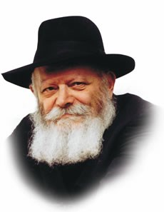

It is in this light that we can understand the words of Rabbi Yosef Yitzchak Schneersohn, the Previous Rebbe, which he uttered before being exiled to the far Eastern provinces of the Soviet Union, where he was sentenced by the Communist regime for the "crime" of spreading Judaism.

Addressing the assemblage of Chasidim who had come to see him off, the Rebbe declared, "...And let all the nations of the world be apprised that it is only our physical bodies that are in galut (exile) and subject to the yoke of the nations. Our souls are not in exile and can never be subjugated! No one can exert any influence over us when it comes to matters of Torah, mitzvot and Jewish practice!"

But what good does it do us to know that our souls are not in exile, if our physical bodies -- the only medium through which we can observe mitzvot and spread the wellsprings of Judaism -- are suffering the hardships of the galut?

The answer to this question comes from our ancestor Avraham, the very first Jew.

Avraham proved that whenever a Jew uncovers the supernatural dimensions of his soul, its G-dly light will illuminate his physical being as well.

In this way the physical body is elevated above the laws of nature, to a plane on which no power on earth can exert any influence.

*Reprinted from the Issue #341 of L’Chaim Weekly (Parashat Toldos 5755/1994)*

**Rabbi Berel Wein**

**On Toldos**

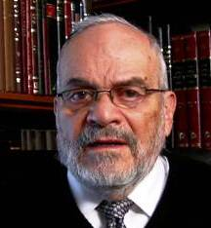

Sibling rivalry is the name of the game.  In fact, the entire book of Bereishis can be described as a narrative of sibling rivalry.  We have Kayin and Hevel, Avraham and his nephew Lot, Yishmael and Yitzchak, Yaakov and Eisav and Yosef and his brothers.  It is as though the Torah wishes to inform and impress upon us the true nature of human beings.

I often think that that is what is meant when the Torah said that the nature of human beings is bad from its onset. We are by nature competitive creatures and the competition always begins at home and with those who are closest to us. We should not think of our children as being angelic but rather deal with their true nature and recognize the pitfalls that natural sibling rivalry will always engender.

Every child is a different world and no two – even identical twins – are the same.  Because of this fact of human nature, competitiveness is built into the structure of all children.  It is the task of education and the home to channel this competitiveness into positive behavior and creative goals.  This is what the Rabbis meant by their statement that the competitiveness between scholars and wise men is a method for increasing wisdom and understanding generally.  Without competitiveness there can be very little creativity or advancement in all forms of life – technology, healthcare, finance, politics and human nature.  The task is to direct this competitiveness towards positive aims and to limit it so that it does not descend into violence and tyranny.

Part of the problem with Eisav is not competitiveness but rather insecurity.  He always feels his younger brother tugging at his heel and preventing him from achieving the greatness that he feels is his due.  Because of this insecurity, he seeks fame and fortune in opposing the ideas and lifestyle of his own very family.  He scorns his birthright because he feels that fulfilling its demands will only inhibit him.  He feels that only by being different than Yaakov can he achieve permanent respect.  As all his plans crumble, he cries out in anguish to his father that he wants the blessings that Yaakov has received. He realizes that only in those blessings, which he will have to share always with Yaakov, can his destiny truly be fulfilled.

This is what Yaakov himself tells Eisav at their last meeting, which we will read about in a few weeks. Eventually Yaakov will come to the mountain of Eisav and then Eisav will be redeemed by his acceptance of Yaakov and of the moral values and tradition of his family. Throughout the books of Tanach, we find this constant struggle of insecurity versus acceptance and competitiveness versus conformity.  We are uncomfortable when we see people who are different than we are.  But the only way to achieve personal greatness is by realizing that our own inner security need not be weakened by competitiveness with others.

*Reprinted from this week’s website of Rabbiwein.co*

**The Cynics**

**By Rabbi Eli J. Mansour**

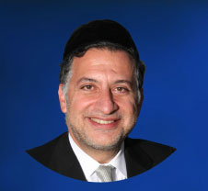

The opening verse of Parashat Toledot introduces the story of Yishak Abinu and his family, and writes, “This is the story of Yishak; Abraham begot Yishak.”  Curiously, the Torah found it necessary to “remind” us that Yishak was Abraham’s son, despite the fact that we are already very well aware of who Yishak was from the previous chapters of Sefer Bereshit.

The Midrash explains that the Torah here tells us not that Abraham begot Yishak, but rather that it was clear to one and all that Abraham begot Yishak.  The “Lesanim” – “cynics” – of the time charged that Yishak was actually fathered not by Abraham, but rather by the Philistine leader Abimelech.  After all, Abraham and Sara were married for many years without children, and then immediately after Sara was abducted by Abimelech, Sara conceived.  The cynics pointed to this as “evidence” that Yishak was not really Abraham’s son.  G-d therefore made Yishak appear exactly like his father, thereby putting to rest the cynical denial of Yishak’s relationship to Abraham.

The Hid”a (Rav Haim Yosef David Azulai, 1724-1806) noted how the rumors spread by the cynics of Abraham’s time are typical of the way cynics speak.  In a certain sense, the claim that Sara conceived as a result of Abimelech was true.  After Abimelech returned Sara to Abraham, Abraham prayed on his behalf, asking that his wives should have children.  In reward for his prayer, Abraham was blessed with a child.  Hence, when the cynics went around proclaiming, “Sara conceived from Abimelech,” they were not lying.  Indeed, the Hid”a notes, the Midrash calls these people not “Resha’im” – wicked people who spread lies – but rather “Lesanim” – cynics.  They spoke the truth, but deliberately phrased in a way that guarantees it would be misunderstood.  Part of the reason why cynics are so dangerous is that they do not lie.  Instead, they find a way to portray all things in a negative light without actually speaking dishonestly.  Liars could easily be dismissed; formulating the truth in a negative, disparaging way attracts an audience.

Ensuring to speak the truth does not always ensure that we speak appropriately.  The truth can be expressed in many different ways.  The cynics excel in spinning the truth to make everyone and everything look bad, so they don’t have to take anything seriously.  We can learn from them the importance of exercising care and caution with regard to not only what we say, but how we say it, and of seeking to find all that is noble an

*Reprinted from this week’s website of the Edmond J Safra Synagogue of Brooklyn website.*

**Thoughts that Count**

**For Parashat Toldos**

*And they called his name Esav...and he called his name Yaakov* (Gen. 25:25-6)

Why is the plural -- "and they called his name" -- used for Esav, but the singular -- "and he called" -- used for Yaakov?

Esav is the father of all falsehood; many are those who find him attractive and seek him out. Yaakov, however, is the source of truth; only the rare individual desires his acquaintance. *(Kli Yakar)*

*And Yaakov was an honest man, a dweller of tents* (Gen. 25:27)

Of all the superior character traits possessed by our ancestor Yaakov, the Torah chooses "an honest man" as the highest praise, to teach us that nothing is more worthy of our respect and admiration than a life lived with honesty and righteous ness. *(Shaloh HaKadosh)*

*Reprinted from the Issue #341 of L’Chaim Weekly (Parashat Toldos 5755/1994)*

**The Shmuz onParshas Toldos**

**The Age of Disrespect**

**By Rabbi Bentzion Shafier**

**Founder of TheShmuz.com**

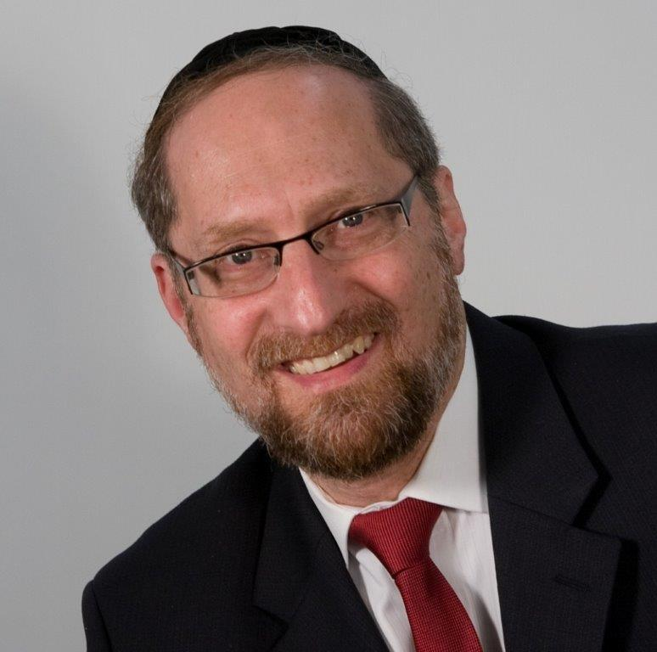

*And Lavan and Besuel answered and said, “The matter stemmed from HASHEM. We are unable to speak to you either good or bad.”* — Bereishis 24:50

Eliezer, the servant of Avraham, went to find a wife for Yitzchak. He approached the city of Charan, waited at the well, and asked HASHEM for a sign. “Let it be that the girl who not only gives me water when I ask for it, but says, ‘Not only will I give you to drink, but I will give your camels as well.’ She should be the one that is right for Yitzchak.”

No sooner did he finish speaking than Rivka, the daughter of Besuel, came upon the scene and fulfilled his request exactly as he specified. Eliezer knew that he had found the right one.

He then asked Rivka to take him to her father. As they neared the house, Rivka’s brother Lavan saw the camels laden with treasures, ran out to greet the new guest and usher him in. Eliezer described the miracles that happened and then asked for approval of the marriage. Lavan and Besuel exclaimed, “It is from HASHEM! How can we stop it?”

Rashi comments that from here we see Lavan’s wickedness. Why did the Torah mention his name first? To teach us that he spoke before his father. This shows us that he was a rasha.

This Rashi is difficult to understand. Why does Lavan’s speaking before his father show that he was wicked? Disrespectful — yes. Rude — certainly. But a rasha?

The answer to this can best be understood from a historical vantage point.

In the 1980’s, a yeshivah student learning in Israel found himself on a bus, sitting near two secular American Jews. Noticing that one was a bit older than the other, he was surprised to hear them calling each other by their first names. “Bob, did you notice that?” said one. “Hey, Joe, what do you think?” said the other. His surprise deepened when in the course of conversation it became clear that the two were father and son. Dad explained, “I don’t want barriers between us, so we call each other by our first names.”

That wasn’t the way that it used to be. In the 1930’s in America, a teenager wouldn’t dream of calling an adult by his first name, let alone his father. And certainly a child wouldn’t dare open his mouth when his father spoke. It didn’t matter how foul-mouthed the child was, and it didn’t matter how unpolished the father was. Children knew their place, and the idea of a child speaking back to an adult was unheard of.

Things have changed a bit since then. The counter-cultural revolution of the 1960’s brought new attitudes and ideas. Police became “pigs.” Government came to be mistrusted. And anyone over the age of thirty was part of the problem. While much of the hysteria of those times has passed, one of the relics is that respect is no longer part of the culture. Gone is respect for leaders. Gone is respect for the clergy. Gone is respect for elders. In its place is the cynicism of a new age — an egalitarian age — where we are all equals.

We no longer need to treat institutions with reverence, and we no longer need to treat authority with deference. And so we argue with our doctors. We argue with our lawyers. And we argue with our parents — who don’t really know that much anyway. Welcome to the Age of Disrespect.

This seems to be the answer to this Rashi. In the times of Lavan, society was still normal. Workers respected bosses. Students respected teachers. Younger people respected older people. As such, there were things that were done and things that were not done. In that world, for a child to answer in his father’s presence was outrageous. It simply didn’t happen. The only time such a thing could occur was when the child had veered way off course — he had become deviant. And so, Rashi tells us that Lavan’s response shows just how wicked he was.

This is especially illustrative because Besuel wasn’t known as a paradigm of virtue. He died trying to poison Eliezer in order to steal his money. Yet, even in his home, for a child to answer before his father did was so out of the norm that it could only happen if that child was wicked.

This concept is relevant to us because while we are a nation, separate and distinct, the reality is that we learn from those around us. And so we need to be mindful of what we consider normal and acceptable behavior. What we see in the world at large isn’t normal — and it certainly isn’t acceptable. We need to teach our children that this isn’t the way. Just because it’s done doesn’t make it tolerable. There will again come a time when people will look back at such behavior with the appropriate sense of horror, shock, and disbelief.

*Reprinted from this week’s website on TheShmuz.com This is an excerpt from the [Shmuz on the Parsha book](https://theshmuz.com/product/shmuz-on-the-parsha-book/).*

**Rabbi Kalman Packouz, zt”l: Giant of Kindness**

**And Innovation**

**By**[**Rabbi Shraga Simmons**](https://www.aish.com/authors/48865357.html)

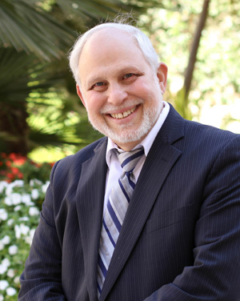

**Remembering one of Aish's original 6 students,**

**and a pioneer of Jewish educational initiatives.**

Imagine you’re a creative, talented and popular 22-year-old headed for law school and a bright future in tech or finance.

Now imagine you become inspired by the power of Torah and devote your life to helping the Jewish people. Over the next 45 years, you raise tens of millions of dollars to fund an array of Jewish educational programs, and pioneer the use of technology to create the iconic Shabbat Shalom Weekly and Western Wall webcam.

You have a multitude of close friends and touch the lives of thousands with persistent acts of compassion and kindness. You are happily married for over 40 years and raise a loving family of nine children and numerous grandchildren, whom you call “life’s whipped cream.”

That was the life of Rabbi Kalman Packouz zt”l, 69, who passed away at his home in South Florida and was buried this week in Israel.

Kalman’s story is of a life very well lived.

Raised in Portland, Oregon, Kalman travelled around the world after graduating college, eventually landing in Israel to work on a kibbutz and go scuba diving. A friend who knew of Kalman’s interest in Judaism gave him the phone number of the great [Rabbi Noah Weinberg](https://www.aish.com/rn/) zt”l.

During a break in the kibbutz program, he traveled to Jerusalem to ask Rabbi Weinberg: “Do Jews believe in the afterlife?” Kalman was drawn to Rabbi Weinberg’s piety, wit and wisdom, and in 1974 – when Aish HaTorah was founded in the Old City of Jerusalem – he became one of its first six students.

Kalman spent long hours with Rabbi Weinberg, absorbing the depth of his teachings: life is for meaning and pleasure; the Almighty loves you; focus on kindness; be an entrepreneur for the Jewish cause.

In 1976, Kalman published the first Aish book for general distribution, *How to Stop an Intermarriage*, a bestseller in Jewish publishing with 6,000 copies sold. Later expanded and retitled as [*How to Prevent an Intermarriage,*](http://www.preventintermarriage.com/) the book offers wisdom and practical advice for Jewish singles and their parents.

**Aish Branch Pioneer**

In 1978, Kalman and his new bride Shoshana drove cross-country to visit his parents in Portland, Oregon. Midway, they spent Shabbat in St. Louis at the home of Kenneth Spetner, upon whom Kalman made a strong impression. Rabbi Weinberg was urged to start the first Aish branch in St. Louis, and Kalman, always eager to embark on new projects, readily accepted the challenge (together with Rabbi Chaim Willis).

With no branch model to follow and no previous experience in fundraising, Kalman succeeded in doubling the branch’s budget in the second year, igniting Jewish pride and forging a model from which all subsequent branches would learn. When asked by an interviewer in St. Louis how successful the Aish branch was, Kalman replied, “One hundred percent successful. Every Jew we have ever dealt with has a more positive feeling about Judaism than he or she did previously.”

In 1982, Kalman returned to Jerusalem to become Executive Director of Aish Jerusalem. During this time he also proudly served in the IDF.

In 1990, the Packouz family moved backed to the U.S., this time to South Florida, where Kalman ran a regional office of the Aish Jerusalem Fund. Over the years, he flew regularly to Hong Kong and other locations, raising tens of millions of dollars for an array of Jewish educational programs in Jerusalem and around the world.

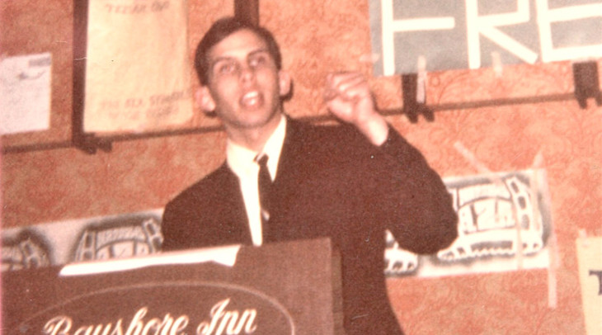**As president of the Bnei Brith Youth Organization group, Kalman speaks at a regional conference (circa 1968).**

**Technology for Torah**

Rabbi Packouz was deeply pained by the disconnect of Jews from their precious heritage, and employed innovative technology to reverse this trend. In 1980, he gained national attention by creating the first-ever Jewish Computer Dating Service (JCDS). Appearing on the *Today Show*, the most popular morning show at the time, Kalman faced a hostile interviewer:

“Rabbi Packouz, now is a time when America is moving away from discrimination. How do you answer those who say your Jewish dating service is based on a premise of discrimination?”

Kalman replied that the matter was not one of discrimination, but of preservation of the species. He shared this analogy: “A group in California is working to save the humpback whale. They feel if the humpback whale becomes extinct, the world and humanity will have lost something precious. Certainly the Jewish people have done more for the world and humanity than the humpback whale?”

Kalman’s second breakthrough with technology came in 1992. In this pre-Internet era, he collected fax numbers of homes and offices, then created a subscriber list for [Shabbat Shalom Weekly](https://shabbatshalom.org/) – a newsletter featuring life lessons from the weekly Torah portion and Jewish insights into personal growth. Stamped with Kalman’s huge smile (and “thumbs-up”) the “fax of life” was warm and witty, with insightful stories, Torah lessons for life, and a pithy “quote of the week.”

What started as a local fax to 50 people, expanded globally and became the gold standard in Jewish adult education. Shabbat Shalom reached into every corner of the globe – posted on office bulletin boards, Jewish community centers, and synagogues. With the mass adoption of email in the mid-1990s, Shabbat Shalom Weekly became the first Jewish e-newsletter to reach 100,000 subscribers.

In 27 years, Kalman never missed sending the newsletter every week. The impact was enormous; to cite one example among thousands, Kalman recently received a call from a man in Israel who forwards Shabbat Shalom Weekly to a friend in England, who in turn forwards it to a woman in Russia – who subsequently became Jewishly-observant and, the caller reported, was being married that evening in Moscow to a rabbi.

Other rabbis adopted Shabbat Shalom Weekly as a tool to maintain weekly contact with donors and students. Kalman was happy that, through his efforts, others did not have to recreate the wheel.

In recent years, Kalman expanded Shabbat Shalom Weekly to three languages – English, Hebrew and Spanish. Then, at the suggestion of a colleague, he created a "Digital Eternity" project, whereby the Shabbat Shalom archives serve as a database to continue sending out a relevant weekly email in perpetuity.

During development of the early Aish website, Kalman stepped forward with another key technological innovation: “[Window on the Wall](http://www.thewall.org/),” a 24-hour webcam on the Western Wall in Jerusalem. Launched in 1997 when webcams were a novelty, the site was selected by *USA Today* as "Internet Site of the Day" and helped put Aish.com on the map.

**Sterling Character**

On a personal level, Kalman was a paradigm of integrity. He worked on himself ceaselessly, molding and shaping his abundant natural strengths to be the best he could be.

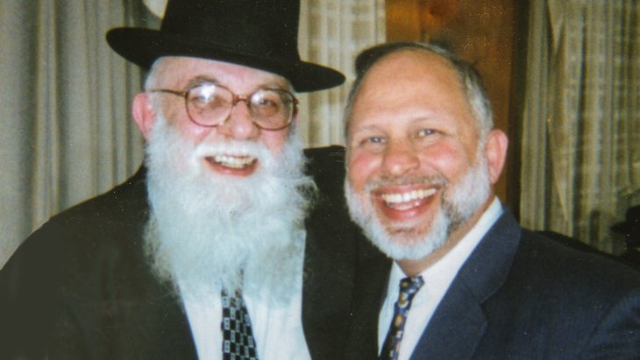

**Kalman with Rabbi Noah Weinberg, zt”l**

When it came to helping others, Kalman had an extraordinary sense of justice; yet for himself humbly abided by the credo that “being kind is more important than being right.” He loved doing the right thing – at any cost – often sacrificing money and pride for the sake of peace.

Kalman had an easygoing demeanor and was a genuine "team player" who enjoyed celebrating others' success. He eschewed competitive and transactional relationships, and did not countenance “success“ devoid of the human caring element – particularly within a team working toward the same larger goal.

As a friend, Kalman was a master of loyalty, kindness, and generosity. He invested heavily in relationships, making extraordinary efforts to stay in touch with hundreds of family, friends and colleagues. He was constantly buying gifts for others. He phoned numerous people every day, and met regularly for breakfast with others. Initially, Kalman did not tell most people that he was sick, not wanting any distract to a fully engaged interpersonal dynamic.

Kalman lived with the ideal that helping others does not mean "begrudgingly acceding to requests." It is rather leaving our comfort zone to proactively "chase kindness.” Like Abraham sitting at the entrance to the tent looking for guests, Kalman would go out of his way to help anyone he saw. He had bottles of water near the front door to give to delivery people. He would make the rounds at hospitals and the local prison, visiting those who are often ignored.

Kalman loved people unconditionally. He made everyone feel important and cared for, spreading love and joy wherever he went. Every interaction was punctuated with his earnest, “What do you need? How can I help?”

He was always ready with a good story or joke, because he loved making people feel good. He would send hand-written thank you notes, and would sign emails: "Much love, beloved friend. You are a blessing in my life!"

Kalman helped other people raise money for their own projects and gave generously himself. Over the course of one year, Kalman wrote 800 checks to charity. In the daily [*Sun Sentinel*](https://www.sun-sentinel.com/news/fl-xpm-2002-03-01-0202270291-story.html), he described his view of *Tikun Olam,* repairing the world, as “a basic human responsibility to reach out to others. Giving of your time and your money is a statement that says, ‘I will do whatever I can to help’."

Kalman always sought to ease others’ pain. Since 1992, he maintained a “Refuah” email list, sent to thousands of people, with requests for prayers on behalf of the sick. At his home in Florida, Kalman frequently hosted a blind, paraplegic man for Shabbat and holidays, volunteering as his private nurse. When he became aware of a stranger whose husband was in emergency surgery, he spent the next hour comforting her.

Kalman was fiercely loyal to his rabbi, Rabbi Noah Weinberg. After Rabbi Weinberg’s passing in 2009, Kalman collected the hundreds of letters of gratitude from former students and, along with photos and eulogies, prepared a 400-page volume entitled “Remembering Rabbi Noah Weinberg,” which he presented as a gift to the Weinberg family.

Kalman worked diligently on his connection with G-d, living with constant awareness of: “What does the Almighty want from me right now?” He was a role model for saying prayers and blessings with mindfulness. In his final hours, barely conscious, he often repeated the words *Ain ode mil'vado* – “there is none besides G-d.”

Kalman was totally devoted to his family, constantly encouraging his children and grandchildren to pursue their dreams. He had enormous respect and appreciation for his wife, Shoshana, and dedicated this week’s posthumous Shabbat Shalom Weekly to her, saying that “All that I have accomplished I owe to her.” (With wry humor, Kalman also dedicated this week’s Shabbat Shalom to his own memory.)

A great light has been extinguished. Rabbi Kalman Packouz was a true mensch whose positive attitude and warm heart inspired thousands. In a parting message, he said: “If you want happiness and joy in life, never miss the opportunity to do a kindness, or express gratitude.”

Every day, find a kindness or express gratitude, in the merit of:

**HaRav Kalman Moshe ben Reuven Avigdor zt”l** הרב קלמן משה בן ראובן אביגדור זצ״ל

Reprinted from the Parashat Toldos 5780 website of Aish.com

**More Thoughts that Count**

**For Parashat Toldos**

*`Two nations are in your womb...and one nation will be stronger Than the other nation* (Gen. 25:23)

"When one will rise, the other will fall," comments Rashi.

Yaakov is symbolic of the Jew's G-dly soul; Esav is symbolic of man's animalistic drives and the Evil Inclination.

When the G-dly soul is strengthened (through learning Torah), the Evil Inclination is weakened without effort, as a natural consequence.

For just as physical darkness is dispelled when one lights a candle, so too is spiritual darkness dispelled when the light of Torah is allowed to illuminate. *(Chasidic Teachings)*

*And the boys grew up, and Esav [Esau] was an expert hunter* (Gen. 25:27)

"Expert at deceiving his father into believing him to be pious and a scrupulous observer of the commandments," comments Rashi, the great Torah Sage.

Esav's hypocrisy is symbolic of our present Exile, in which the forces of evil are not as readily identifiable as they were during previous exiles. It is for this reason that our Exile is termed "Galut Edom" ("the Exile of Edom"), for the nation of Edom is descended from Esav.

When Moshiach comes, the "Deliverers will go up to Mount Zion to judge the mount of Esav, and kingship will be the L-rd's." *(Lubavitcher Rebbe, Toldot, 5750)*

*Reprinted from the Issue #341 of L’Chaim Weekly (Parashat Toldos 5755/1994)*